Application for Training
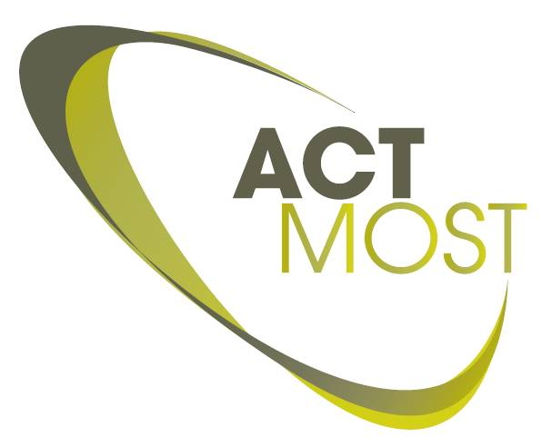

Practical information
To be completed by the ACTMOST trainee responsible

To be completed by the company

ACTMOST trainee responsible
Name of trainee responsible:
ACTMOST partner:
Tel: |  | fax:
email:

Company info
Name of the company:
Department :
Website:
 | Address: |  |  | Country:
 | Type of company : | SME Large-scale company
Comment: |  | [How big is the company in size of revenues or number of employees and when is the company founded]

Company contact PERSON
Name of contact person :
Title:
Tel: |  |  |  | fax:
email:

General training information
Title of the training:
Agreement on the confidentiality: | ( Please add the signed NDA in attachment if appropriate)

Agreement about the conditions of the training contract: | ( Please add selected contract template in attachment , not signed yet)

Involved ACTMOST partners:
Involved ACTMOST access centers
( first indicated access center is the main unit assigned to this project ):
Is there any existing or former bilateral collaboration between Company and ACTMOST partner(s): | Yes / No

Detailed training information – part I

Abstract:

Scope of training:

Potential dates for training:

Training language:

Description training contents and training duration for each ACTMOST partner involved

Partner 1 + responsible person

Partner 2 + responsible person

Budget

ACTMOST partner 1 | Number of days  Personnel cost  Consumables cost  Total indirect cost  TOTAL for partner 1  Cost carried by partner 1

ACTMOST partner 2 | Number of days  Personnel cost  Consumables cost  Total indirect cost  TOTAL for partner 2  Cost carried by partner 2

Summary | Total cost of training  Support requested from ACTMOST  Total cost for company  Cost carried by partners

Detailed training information – part II

Main motivation for training:

Expected impact for the Company:

Trainees:

Trainee 1
Name

Short CV

Background knowledge

Trainee 2
Name

Short CV

Background knowledge

Trainee 3
Name

Short CV

Background knowledge

