Evaluation report
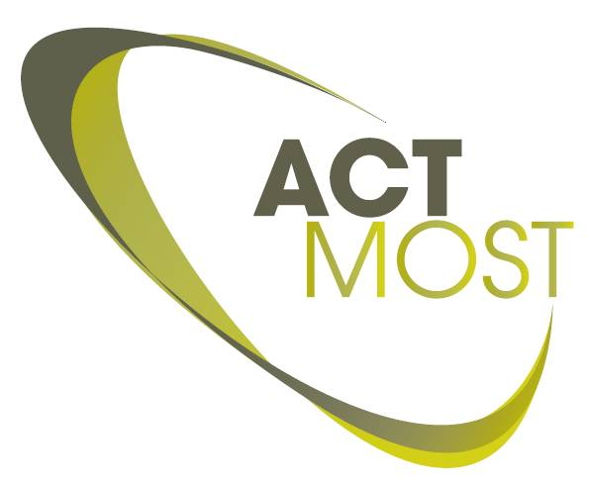
Application training

ACTMOST Training responsible
Name of project leader:
ACTMOST partner:
Tel: |  | fax:
email:

Company info
Name of the company:
Department :
Website:
 | Address: |  |  | Country:
 | Type of company: | SME Large-scale company
Comment:

Company contact PERSON
Name of contact person:
Title:
Tel: |  |  |  | fax:
email:

General project information
Title of the User Project:

Involved ACTMOST partners :
Involved ACTMOST access centers
(first indicated access center is the main unit assigned to this project):

Eligibility criteria

The table below shows an overview of the eligibility criteria for an ACTMOST user project. All criteria should be fulfilled in order to get access to the ACTMOST subsidy model.

The European identity of the potential user ( company) | OK
The pre-competitive character of the request | OK
The suitability of the request as pilot project for ACTMOST | OK
The type of support activity (dedicated training, user project involving one or more units of the food-chain, etc) | OK
The demonstrable capacity of ACTMOST to accomplish the request | OK
The appropriateness of the proposed coordinator, partners and consortium to take on the request and bring it to a successful ending | OK
The requested financial support and whether it is commensurate with the request ( if not ok please fill in * ) | OK
The conformity of the request with the general objectives of the EC Photonics Unit | OK

It can be concluded that all eligibility criteria are fulfilled.

Eligibility criteria

Eligibility criteria

Evaluation criteria

The table below shows an overview of the score on the different evaluation criteria. The project has been evaluated in two different parts. Both parts consists of different criteria points. Each criteria is scored with a value from 0 (under performed) to 10 (excellent). Each criterion has a certain weight. The score is multiplied with this weight. If for example the weight is 3 the max for this criterion is 30 points in total. The overall total of each Part individual should be at least 70 points (70/100 ). If this overall threshold is not reached the project cannot be accepted.

 | Evaluation criteria - Part I | Score | Weight | Total | Threshold
1 | The innovative dimension for the company:  - What are the chances that the knowledge will indeed be needed on the short/mid long term?  - What is the impact of the training on the innovation process of the company? |  | 5
2 | The collaboration between the partners  - Is the project initiating a new collaboration between the industry and one of the research partners? |  | 2
3 | Type of the company (SME = 10; LS = 5) |  | 2
4 | Former support:  Did the company receive ACTMOST support on a previous occasion?  (priority goes to users that have not received support before)  No support = 10; Previous support= 0 |  | 1
Total |  |  |  |  | 70

 | Evaluation criteria - Part II | Score | Weight | Total | Threshold
1 | The maturity of the company / dynamic & entrepreneurial character / credibility  Has the company a proven track record of bringing new products/solutions to the market? |  | 2
2 | The level of commitment of the company:  What is the involvement and effort brought in by the company (number of trainees, level of trainees). |  | 2
3 | Quality of the training program and trainers:  Are the proposed ACTMOST partners well positioned to carry out the training?  Is the training program well defined and in line with the pre-defined scope? |  | 3
4 | Quality of the trainees:  Have the trainees the right background to follow the training sessions? |  | 3
Total |  |  |  |  | 70

Evaluation comments and conclusion

